**Projects**

*Figma low-fi & high-fi prototypes of portfolio*

<https://www.figma.com/design/Oo6GLQUolyw6YTXA1C0jam/Portfolio-sem3?node-id=0-1&p=f&t=TqBaUwpXd0LnO8OM-0>

STUDIO CREATION

*Abstract*

This project is divided into different phases where we formed groups, created a studio brand identity and selected a real-world client to work for and apply our skills in a practical setting.

***Ideation***

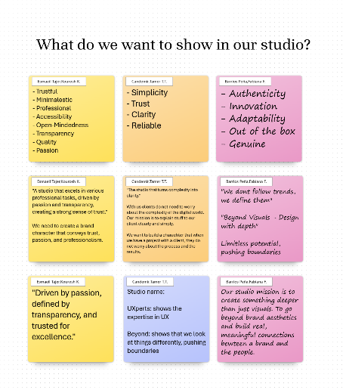We brainstormed ideas of what things compose a brand, based on that we specified concepts to create our own studio.

Inspiration

We had a HCD workshop where we identified problems people face when eating chips and came up with possible (some already existing) solutions. I made this concept map with the ideas my group and I discussed to represent it in a more visual way. This activity is loosely aligned with the double diamond method as we followed this framework in a small scale.

Discover: identified problems when eating chips

Define: narrowed down key dilemmas (excluded less important one like chopsticks etc)

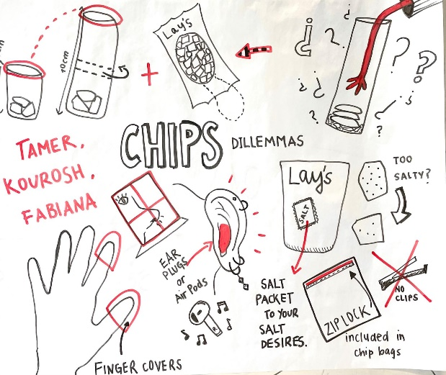Develop: brainstormed solutions,

Deliver: visualized potential solutions

I made a mind map with our new ideas for the new studio identity.

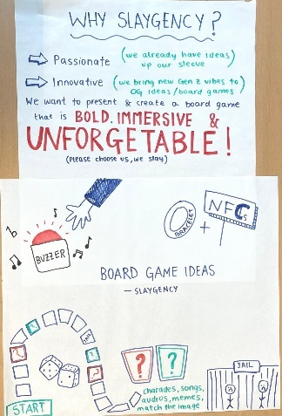After the clients were presented to us, we discussed what options would fit our studio better. Before starting the motivation that would eventually get our prefered clients to choose us I created this rough draft of why the Slaygency is the best fit.

I finally created a video that showcased our main points as our motivation to work for the Boardgame client.

(video attached separately in the assigment)

***Design***

We wanted our studio name to align with its mission, create something deeper than just visuals, to go beyond brand aesthetics and build real, meaningful connections between a brand and the people. For that, all group members unanimously agreed on the name “Beyond”, as it aligns with our brands main core values : innovation, trust, quality, and reliability.

I sketched my initial ideas of possible logo options. I later tested variations in colour, size, and shape to find a balance between clarity, professionalism, and creativity. Additionally, I created a moodboard + stylescape for what i thought would match Beyond better.

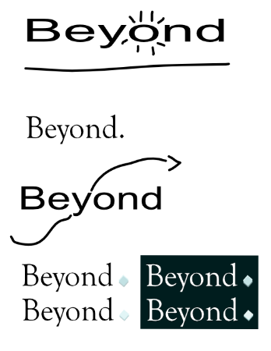

Feedback

Several teachers expressed their opinions of lack of identity of our studio, it was boring and bland, even though we met all the requirements. As a group, we decided to re-brand and create something bold and unforgettable.

***

We made a new moodboard each and collectively chose several elements from each other’s. Later I combined all these elements into a singular, final stylescape for our new studio: SLAYGENCY. Additionally, I created a Brand poster as well as a team poster to represent our studio to others.

**

***Reflection***

We wanted our studio name to align with its mission, create something deeper than just visuals, to go beyond brand aesthetics and build real

PORTFOLIO

*Abstract*

This project is divided into different phases where we formed groups, created a studio brand identity and selected a real-world client to work for and apply our skills in a practical setting.

STUDIO CLIENT

*Abstract*

This project is divided into different phases where we formed groups, created a studio brand identity and selected a real-world client to work for and apply our skills in a practical setting.

**Learning Outcomes**

(Any image in this section will be a link in the actual portfolio but I’m having trouble uploading the files to drive right now)

***LO1 - Conceptualize, design, and develop interactive media products***

*You create engaging concepts and translate them into interactive validated media products by applying user-centered design principles, visual design techniques and by exploring emerging trends and developments in media, design and technologies.*

* ***Target Audience*** *(DEFINITION)*
* ***Target Audience****(VALIDATION)*
* ***Concept*** *(DEFINITION)*
* ***Concept*** *(VALIDATION)*
* ***Design*** *(Wireframes, low+high fid)*
* ***Design*** *(VALIDATION) 🡪*
* ***Interactive product*** *(itself)*
* ***Interactive product*** *(VALIDATION)*

Evidence links

Portfolio Figma: <https://www.figma.com/design/Oo6GLQUolyw6YTXA1C0jam/Portfolio-sem3?node-id=0-1&p=f&t=IIXLWZoBQp4qScjI-0>

HCD workshop

Reflection

***LO2 - Transferable production***

*You document and comment your code using version control in a personal and team context and communicate technical recommendations.*

* ***Git repository***
* ***ReadMe in Git***
* ***Commits and Branches***
* ***Code documentation***

Evidence links

Reflection

***LO3 - Creative iterations***

*You present the successive iterations of your creative process, and the connections between them, of your methodically substantiated, iterative design and development process.*

* ***Clear starting points***
* ***Reasons for iteration***
* ***Before and after***
* ***Validation for iteration***
* ***Iterations on multiple areas***

Evidence links

Branding Before & After

Reflection

***LO4 - Professional standards***

*Both individually and in teams, you apply a relevant methodological approach used in the professional field to formulate project goals, involve stakeholders, conduct applied research, provide advice, make decisions, and deliver reports. In doing so, you keep in view the relevant ethical, intercultural, and sustainable aspects.*

* ***Design challenge/ HMW-questions***
* ***Summary process***
* ***Advisory report***
* ***Ethical considerations***
* ***Research questions and methods***
* ***Multiple DOT framework areas***
* ***Conclusions***
* ***Translations to project***
* ***Triangulation***
* ***Scrum***

Evidence links

*MOTIVATION VIDEO (*analysed potential clients and discussed which projects best fit our studio/vision. I drafted our pitch motivation and later translated it into a video to communicate our strengths. choosing the right clients and presenting work *professionally)*

Reflection

***LO5 - Personal leadership***

*You are aware of your own strengths and weaknesses, both in the field of ICT and in your personal development. You choose actions in line with your core values to promote your personal growth and develop your learning attitude.*

* ***Exploration for self*** *(SWAT)*
* ***Exploration of job vacancies***
* ***Feedback*** *(ASKING AND APPLYING)*
* ***Attending events***

Evidence links

*MOTIVATION VIDEO (*self-awareness of my strengths and weaknesses in both design and teamwork. Taking initiative to edit a video and handing in something that will make my team stand out)

Feedpulse (individual)

Feedpulse (group)

Reflection